THE LIGHTHOUSE MINISTRY

WHAT IS DEMENTIA
CHANGES IN BEHAVIOUR WITH DEMENTIA
PREPARING FOR COMMUNICATION
SPEECH
COMMUNICATION
ORIENTATION
UNDERSTANDING RESPONSIVE BEHAVIOUR
ENVIRONMENTAL
OTHER CAUSES

THANK YOU!
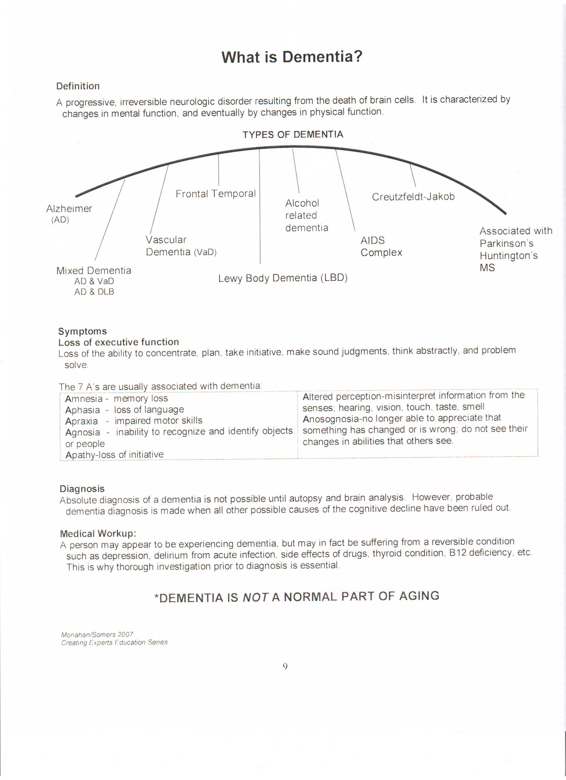
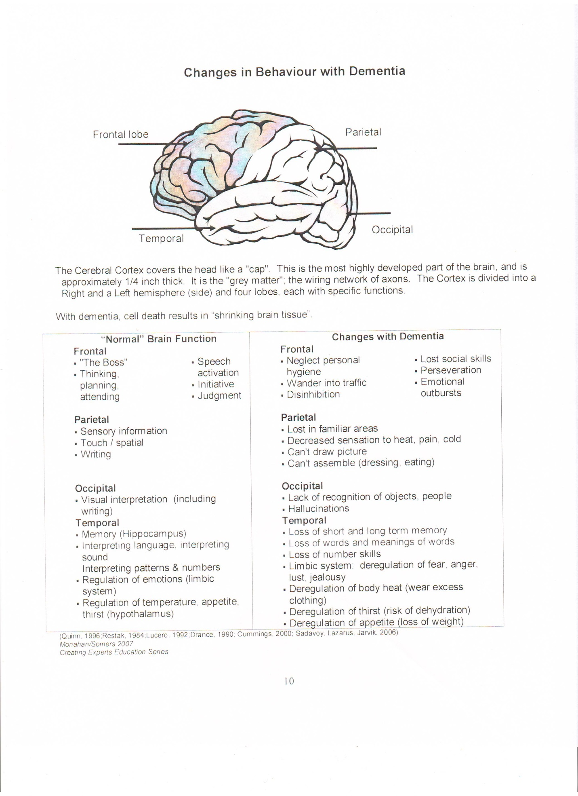
_{PREPARING FOR COMMUNICATION}
Be aware of the person’s best ear. Speak to the person in in a quiet room without TV, radio, other people talking or other distraction. Be aware of ethnic language differences as many words have similar sounds but very different meanings. Always approach a person from the front. Never come up from behind, as they may get startled. Gently touch the person before speaking so they are aware of your presence and your intention to speak to them. Identify yourself to the person each time if necessary. Always when possible be on the same level and make eye contact. Maintain eye contact to ensure the person is attentive to the conversation. Be aware of where their arms and hands are so as to not provoke an altercation. If the person usually wears glasses, ensure the person is wearing them so he/she can see you are talking and can see the mouthing of words if the person has impaired hearing. Be attentive and stop to answer any questions the person may ask. Do not talk to the person when you are on the run; as only part of what you are saying may be heard. Please sit down and make eye contact. Remember, each person is important; so be patient and take the time to answer any question the person may be asking. Speak using short sentences that come directly to the point. Don’t talk over the person, always include him/her in all conversations when he/she is present. Loud noises can startle the person and cause fear or agitation. If possible identify the noise.
_{SPEECH}
Loss of speech does not mean loss of mind or thinking ability. Only one person should talk at a time. Try not to overwhelm the person with too many words or questions. Do not shout! Speak slowly, calmly, clearly and as naturally as possible. Always maintain eye contact and use a tone of voice appropriate for the adult person. Allow sufficient time for the person to respond. Speak in simple concrete sentences or phrases that are easy to understand. Use gestures and body language to reinforce communication. If necessary, use pictures to communicate effectively. Always approach the person in a calm relaxed manner to make the person feel comfortable. This often will enhance the person’s ability to talk. Make yourself visible so the person can see who is speaking. Take the time to listen to each person; this will prevent the person from withdrawing from family and life activities. Try not to change the subject when the person is speaking. The person may need time to shift his/her thinking to correspond with your story. Use simple repetitive words when introducing a new activity or craft. The person’s emotions may change quickly with little or no reason. Don’t be upset by this, just wait for the person to relax again. Always be sure to praise the person for his/her efforts as well as successes. Don’t be alarmed by swearing or profanity; often this as meaningless as it is involuntary. Don’t make an issue of it. Don’t interrupt the person’s thinking process by unnecessary comments; this may make it difficult for him/her to get their thought process back on track. If a person is having difficulty expressing an idea, fill in the gaps or may an educated guess. Try to work it out together. If the person is having a difficult day communicating with words use an activity as a mode of communication. Be flexible. If the person tends to repeat over and over the same words try using distraction with an activity. Be flexible. For example: change the subject, sing a familiar son or talk about the feelings behind the statement. Try asking a question “what were some of the games you played as a child?”
_{COMMUNICATION}
Avoid asking questions that rely only on memory. Don’t try to reason with the person; the person may not have the ability to rationalize. Reasoning or rationalizing with the person often leads to frustration and then anger. Try not to express your frustration or impatience verbally or with body language. Remember, the person’s feelings are still intact. In fact, feelings are one of the last senses lost. A person with dementia can often have a very low level of tolerance, and can often become frustrated and agitated if they feel threatened or confused. When communicating to the person tasks involved in an activity, state the directions clearly for each step. Complete one step at a time. Avoid open-ended questions. Rather offer simple instructions. Decision making may be overwhelming to the person and the response may be one of agitation or anger. Don’t take this personally; just try to understand this is not the person’s normal reaction. Try to diffuse the situation by using a distraction of activity or topic. Be flexible.

_{ORIENTATION}
Time and Date are important. The place is Fellowship hall at Fellowship Baptist Church. Person: We are so happy you were able to join us this morning. Welcome to the Lighthouse program! Have the caregiver/spouse sign the consent form and let them know the time to pick up their family member. Make a name badge for the visitor. Show the person where the washrooms are. *Watch for any visible signs that indicate the person may need to use the washroom. Be discreet when asking the person if they would like to use the washroom.
UNDERSTANDING RESPONSIVE BEHAVIOUR
Behaviours seen and displayed in persons with dementia are almost always a response to something in the person’s environment. Responsive behaviours include: agitation, restlessness, apathy, disorientation, sleep disturbance, pacing, wandering, and verbal outbursts or acting out. These behaviours are a person’s best response to what they understand is happening in their own environment. All behaviour has a meaning and to understand the meaning of the behaviour, it is important to see the world from the perspective of the person with dementia. I always told my volunteers “You need to step into the world of the person with dementia but when the program is over, you must step back into your own world.” This is very important as a volunteer! When you are able to do this you will be a valued volunteer. Always ask permission to give the person a hug or handshake.
_{ENVIRONMENTAL}
Some of the environmental factors with persons with dementia are: Sensory Overload: too much noise, activity, clutter or too many people in the environment at one time; which can lead to over-stimulation. Unfamiliar People, place or sounds. Sudden movements; startling, unexpected noises. Feelings of insecurity; being lost or forgotten. When the spouse or familiar caregiver is out of sight the person with dementia may feel frightened or abandoned. Difference in lighting of the area can cause confusion and agitation.

_{OTHER CAUSES}
- Being asked to respond to several questions or statements at once
- Emotional reaction to arguments, stress, irritability or frustrations of others
- Feel like they are being scolded, confronted or contradicted
- _{Feelings of embarrassment}
- Surprised or startled by unexpected physical contact
- The frustration of being unable to perform what used to be a simple task
- Unable to understand what exactly they are expected to do
- Unclear instructions or too complicated
- Any form of change in schedule or routine
- _{Short attention span}

_{THANK YOU VOLUNTEERS!}
Thank you for your gift of volunteering. You are about to make a difference in someone’s life with your gift. Not only will the person with dementia be blessed, you too will be blessed beyond measure. So we are about to embark on a journey, hang on and watch what God has in store for these dear people and what His plan is for you!
Matthew 5:16 Let your light so shine before men, that they may see your good works, and glorify your Father which is in heaven.

_{Pauline Swaren}

